ABOUT CURRUMBIN WILDLIFE HOSPITAL

Currumbin Wildlife Hospital first opened in 1989, to provide urgent care to our local wildlife. Today, it’s grown to be one of the busiest wildlife hospitals in the world, treating, rehabilitating, and releasing around 15,000 wildlife patients and 275 species every year. This service is provided free of charge to the community.
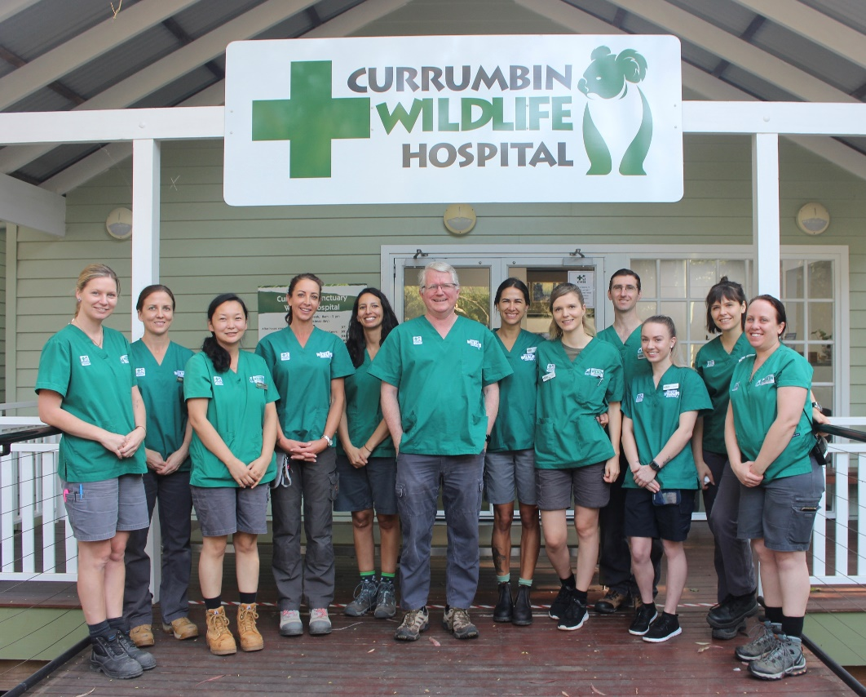
In the last 30+ years, more than 150,000 sick, injured, and orphaned native wildlife animals would have struggled to survive without the support of the community and the lifesaving treatment by the incredible team of wildlife veterinarians, nurses, volunteers, and network of carers. As the admissions continue to rise each year, so does the need for community support and donations. This support ensures the hospital releases hundreds of native animals back into the wild every month.

ABOUT NATIONAL TRUST & CURRUMBIN WILDLIFE HOSPTIAL

Currumbin Wildlife Hospital is owned and cared for by The National Trust of Australia (Queensland) established by state legislation in 1963 as a Not-for-Profit organisation governed by an independent Board of Directors.
National Trust of Australia (Queensland) Limited (ABN: 85 836 591 486) [“NTAQ”] has the following characteristics as an entity:
- A registered charity under the Australian Charities and Not-for-profits Commission (“ACNC”) law; and
- Listed by name in Item 6.2.15 of table in section 30-55(2) Income Tax Assessment Act 1997 as a specific deductible gift environment recipient (“DGR”)
The Currumbin Wildlife Sanctuary and Currumbin Wildlife Hospital were given to the National Trust in 1976, the success of which honours the vision of the founder Alex Griffiths and underpins the achievements of the charity as a whole based on the vision of the founding members of NTAQ in 1963.

YOUR LEGACY, THEIR FUTURE

Leaving a charitable bequest to the Currumbin Wildlife Hospital in your Will is a very special and enduring way to protect the future of Australia’s native wildlife. Your legacy will be a lasting one, as these animals are released back into the wild to breed and produce future generations of wildlife.
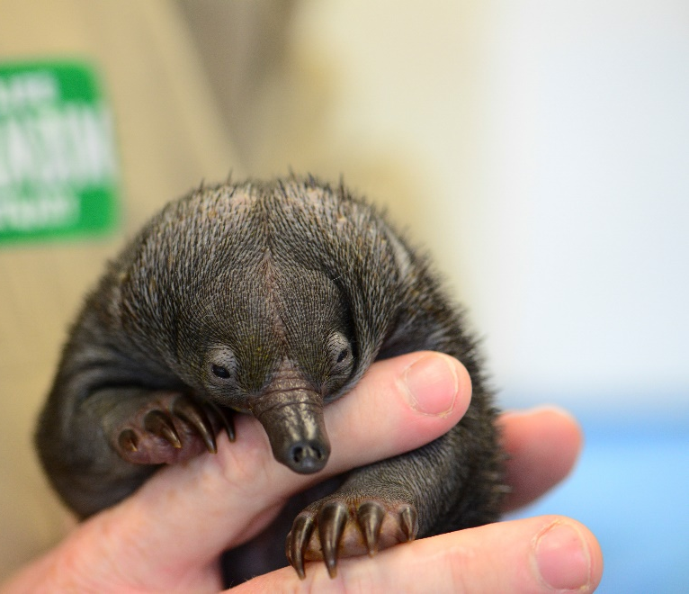
What your gift can do:
- Provide veterinary treatment for sick, injured, and orphaned native wildlife and save countless lives
- Support research and conservation programs
- Fund essential medical equipment

“Whether your bequest is large or small, it will make an immense difference in helping native wildlife”
– Dr Pyne

How to remember Currumbin Wildlife Hospital in your will?

A gift in your Will to save Australia’s native wildlife is surprisingly easy to do. You can gift a specific sum of money, a specific asset, a percentage of your estate or a nominated percentage of the remainder of your estate. Ask your solicitor or other qualified professional to assist with wording that suits your wishes best.
For example:
‘I give:
(a) the residue (or percentage) of the residue of my estate; or
(b) the sum of $(amount); or (specified items) to the National Trust of Australia (Queensland) Limited’s Currumbin Wildlife Hospital (ABN 85 836 591 486) to be held upon trust and to be applied towards activities associated with the provision of treatment, care and rehabilitation services to Australian native wildlife, including the funding of the Currumbin Wildlife Hospital to enable it to provide veterinary treatment for sick, injured or orphaned Australian native wildlife.

Details for Currumbin Wildlife Hospital

Name of Charity
National Trust of Australia (Queensland) Limited’s Currumbin Wildlife Hospital
ABN: 85 836 591 486
Address for National Trust of Australia (Queensland) Limited:
2/19 Mary Street
Brisbane
QLD, 4000, Australia

Bank Account Details for Currumbin Wildlife Hospital
Bank name: Westpac Bank of Australia
Beneficiary Name: National Trust of Australia (Queensland) Limited’s Currumbin Wildlife Hospital
Beneficiary Address: 27 Millers Drive, Currumbin, 4223
BSB Number: 034 0604
Account Number: 427 342
SWIFT Code: WPACAU2S

